Medical Research Program: Applicant Guide

REGISTRATION PROCESS
- Access the Grants Portal.
- If you are a returning user, proceed to Login. If you are a new user, click “Register.”
- Select the registration option “Principal Investigators applying to Medical Research Funds.”
- Enter all of the applicable contact information and click “Submit.”
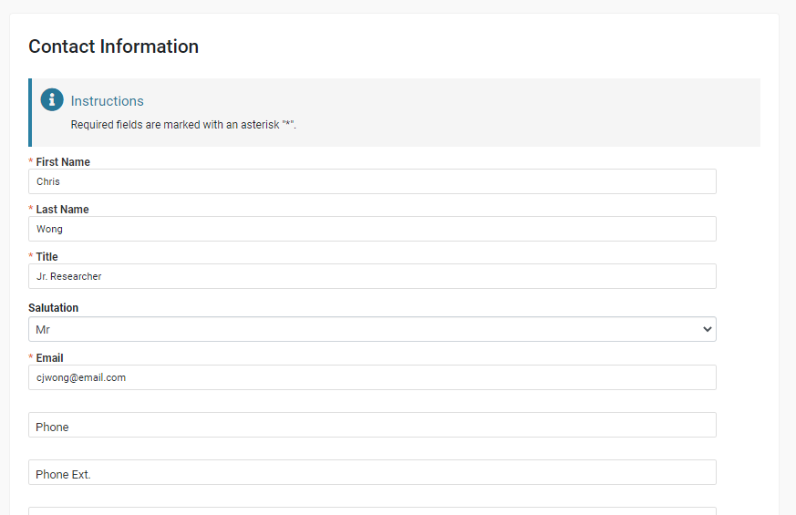
- You will receive a verification email with the subject line “New User Information.” Click the “Set Password” link within the first 24 hours of creating the account. If that time frame has passed, use the “Forgot Password” link on the main login page.
- After you set your password, you will be directed to the landing page of the Grants Portal.

GRANTS PORTAL
This is your Grants Portal, where you can access active Medical Research grants, post reports, update your profile, submit applications for open Medical Research grant rounds, and view previous applications that you have submitted. Please note, as of 1/18/2022, as HCF continues to make its transition to the new Grants Portal, you may not see your current active grants with HCF. These will be imported once we complete the transition later in 2022.

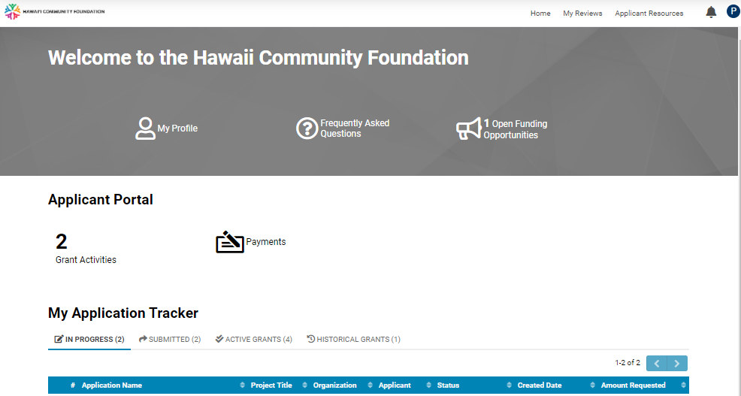

SHORTCUTS
My Profile
View and edit your personal contact information.

Frequently Asked Questions (FAQs)
Find answers to your most frequently asked questions about the portal and grant application process. If you have specific questions about the Medical Research grant program, please contact Nanda Freeman, Sr. Program Associate, or Tricia Mabellos, Program Officer.

Open Funding Opportunities
View all of the available funding opportunities.

APPLICANT PORTAL TILES
Grant Activities
View a list of scheduled reports or conditions for payment release related to your grants. You may submit grant activities through your Grants Portal unless your Research Institute is submitting on your behalf. If you have trouble submitting documents, please send them to Medres@hcf-hawaii.org and include your application ID number.

Please note, as of 1/18/2022, as HCF continues to make its transition to the new Grants Portal, you may not see your current active grant activities with HCF. These will be imported once we complete the transition later in 2022. If you need to submit reports or conditions for any active grants that do not currently appear in your Applicant Portal, please contact the staff on your original Grant Award Letter.

Payments
View a list of scheduled payments.

My Application Tracker
- In Progress: Applications that have been started, but not submitted. This list may also include applications that have been previously submitted and have been returned to the applicant with a request for additional information.
- Submitted: Applications that have been submitted. Once an application has been submitted, the applicant will no longer be able to make changes to the application.
- Active Grants: Applications that have been approved and awarded a grant.
Please note, as of 1/18/2022, as HCF continues to make its transition to the new Grants Portal, you may not see your current active grants with HCF. These will be imported once we complete the transition later in 2022. If you need to request changes to any active grants that do not currently appear in your Applicant Portal, please contact the staff on your original Grant Award Letter.
- Historical Grants: Grants that have been closed and declined applications You will be able to access award or denial letters through the Active Grants or Historical Grants tabs in the portal.

Top Right Navigation

- Home: Click here to return to the Grants Portal landing page
- Applicant Resources: Click here to access additional resources if referenced in Funding Opportunity guidelines
- Notifications (Bell Icon): Click here to see notifications related to your account
- Account Settings (Circle Icon): Click here to update your profile or password

SUBMITTING AN APPLICATION
- Log in to the Grant Portal.
- Click “Open Funding Opportunities”
- Find the applicable RFP in the list and click “View” to view the guidelines, then click “Apply” to start your application.
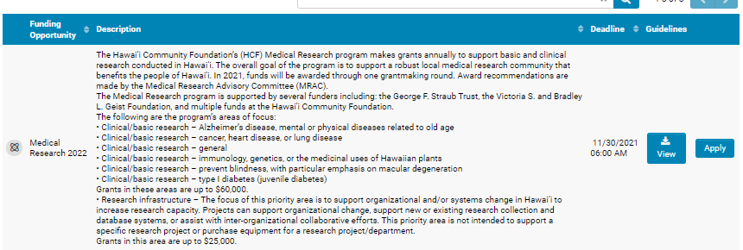

- Review the notes and instructions and click “Begin Application.”
- Fill in the required fields and click the “Next” button on the bottom right, or click on the subsequent tabs to complete the application.
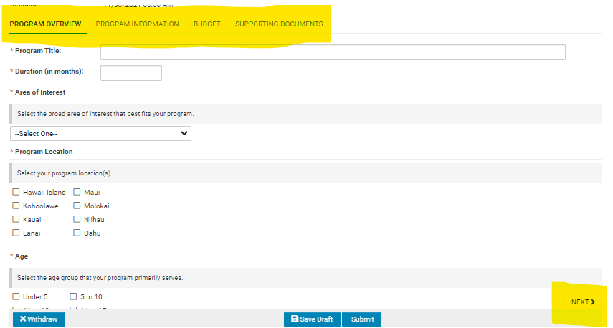

- After completing the information in all four tabs and uploading the required documents, click “Submit.”
- If any required fields have not been completed, you will receive an error notification. You can click any error in the notification box to be directed to the specific field to complete.
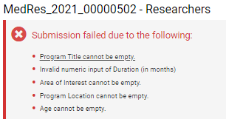

- Upon completion, you will receive an email indicating that your submission is complete. If any further follow up is needed, you will receive emails from the Grants Portal. Please make sure that you mark any emails from donotreply@hawaiicf.com as safe so that they do not go into your spam box. You can access all submitted applications in the My Application Tracker of your home page.

